Name: Zheng Wen

ID:　ni7779

Program #2

I use uniform algorithm. The sizes of pictures are 65KB, so I use 256*256*8=65536 to present pictures. I divide pictures into 16 levels，so my step size is 16. After that, I compress each pixel from 8 bits to 4bits. After compressing, the sizes of pictures are from 65KB to 33KB, so the ratio is 2:1.

* Encode & Decode:

I use two C programs to encode and decode pictures. The first program names encode_lossy.c. I use it to compress pictures. In encode part. I use ‘&’ operation to overlap two pixels, so 8bits represent two pixels of original picture after compressing the picture. Then second program names decode_lossy.c. I use it to uncompress pictures. It takes an adverse operation to encode program. However, my program is not good enough; it cannot decode the re-constructed picture as well as original picture.

* Compile:

First, I use command prompt to compile encode_lossy.c and decode_lossy.c. After compiling, system produces encode.exe and decode.exe. Finally, I use encode.exe to encode pictures, and use decode.exe to decode pictures. The whole process following:

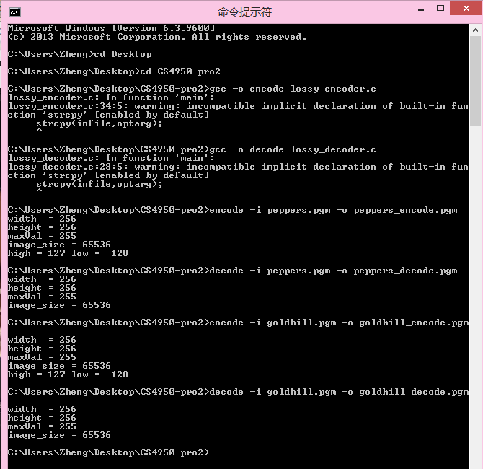

* Encode & Decode result:

The results of decode program is not good enough. The re-constructed pictures are not as well as original picture.

